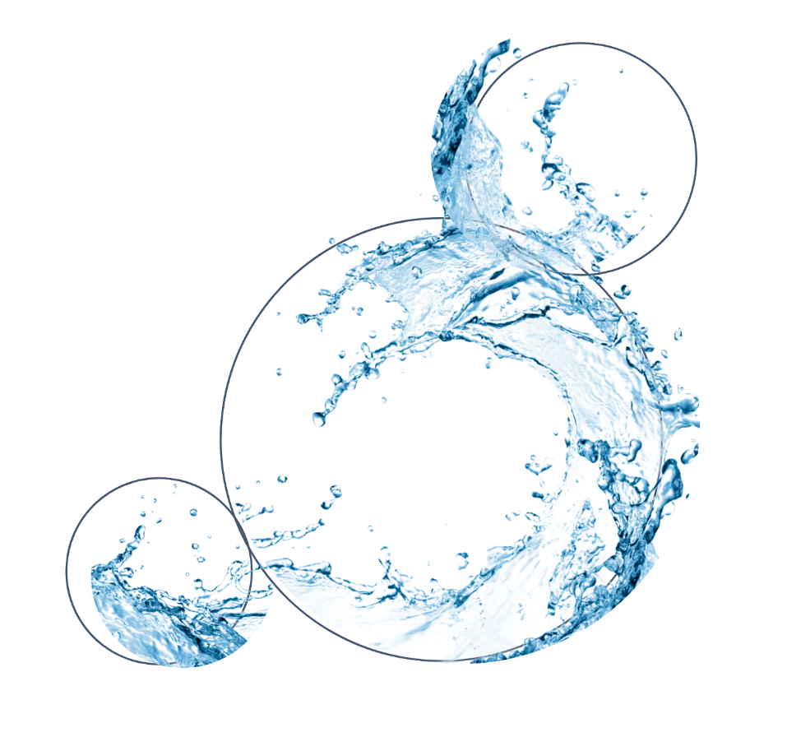

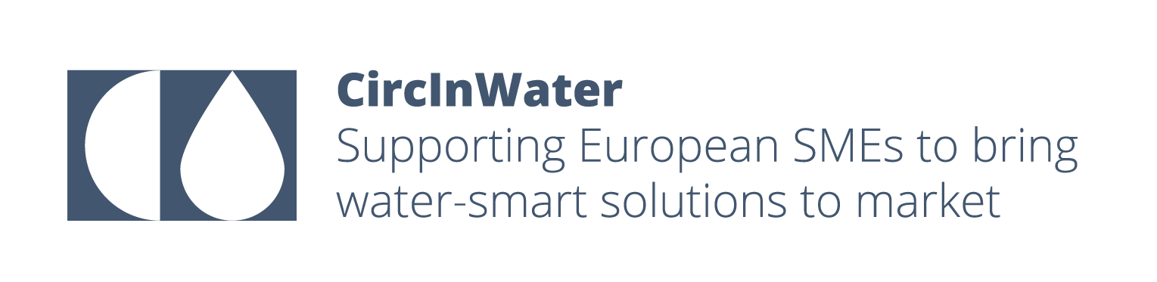

CircInWater Innovation lump sum
Application Form Template

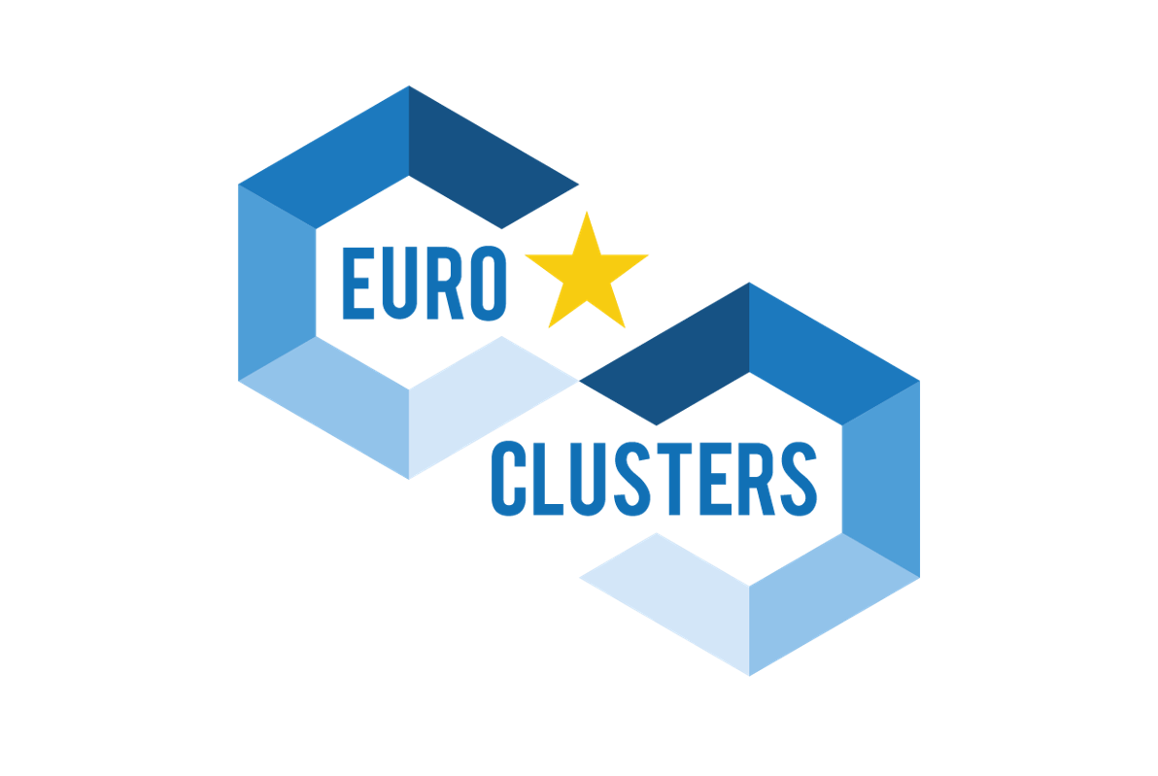
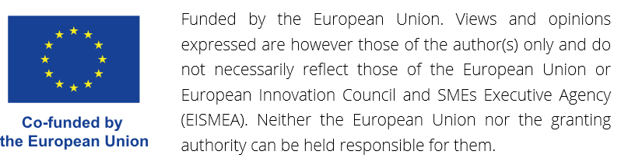

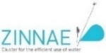
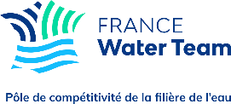
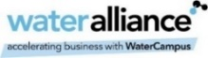
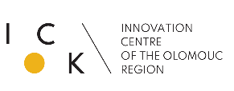
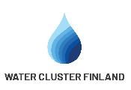
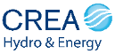

Index

General public information 1
Project publishable summary 1
Section 1. Administrative and legal information 2
1.1 Project partner information 2
1.2 Eligibility check 4
1.3 Additional project information 5
Section 2. Project description 7
2.1 Excellence (Total score: 40 points) 7
2.2. Impact (Total score: 40 points) 9
2.3 Quality and efficiency of the implementation (Total score: 45 points) 11
Section 3. Declarations 15
3.1 Online Declaration of honour 15
3.2 Application submission 15

Important note for applicants
This document is a Word version of the Application Form for the CircInWater Innovation lump sum. You can use it to work offline on your application.
Please note, however, that this is not the official Application Form. CircInWater applicants must apply by completing and submitting an online Application Form via the CircInWater submission platform. Application forms received in any other way will not be considered.

General public information
Title of Proposal: | Acronym

Duration in months
Please select the industrial ecosystem that best matches your proposal:
☐ Agrifood ☐ Energy-intensive industries
Type of project:
☐ Individual ☐ Collaborative
Specify the total number of Project Partners (including the Project Coordinator) involved in the project.
Enter the total number of Project Partners (those requesting funding), considering that the maximum number of SMEs that can be involved in a collaborative project is 3.

Project publishable summary
The abstract should provide the reader with a clear understanding of the proposal’s objectives and how they will be achieved. It should address in particular the following aspects: objectives, main activities, and expected results. This summary will be used as the short description of the proposal in the evaluation process and will also be published if the project is selected for funding.
[Type your answer here. Your answer must not exceed the characters limit indicated below]
(max. 2000 characters, including spaces)
Note: The innovation projects could be individual, with one single SME, or collaborative, with 2-3 SMEs (Section 3. Application process in ‘CircInWater innovation lump sum – Guide for applicants’). In the case of a consortium of 2-3 SMEs, all the information requested in Section ‘1.1. Project partner information’ and ‘1.2.1 Eligibility check-Participants eligibility’ needs to be provided by each ‘Project Partner’ individually (Project Coordinator, Partner I and II), in the CircInWater submission platform, if funding is requested.

Section 1. Administrative and legal information

1.1 Project partner information

1.1.1 General information about your company (Project Coordinator, Partner I and II)
Company Name
Company Address: Street name and number
Postcode |  | City
Region |  | Country
Webpage
Social media networks (Twitter/LinkedIn)
Company VAT Number
Sector of activity
Cluster membership
Number of employees 2022
Profit and loss for the financial year 2021 (€)
Balance sheet 2021 (€)
Provisional profit and loss for the financial year 2022 (€)

1.1.2 Contact Person (Project Coordinator, Partner I and II)
Title (Mr., Mrs., Ms., Mx.)
Full name
Position
Email Address
Phone Number

1.1.3 Company Profile (Project Coordinator, Partner I and II)
Explain briefly what your company is about, e.g., your business activities and expertise.
[Type your answer here. Your answer must not exceed the characters limit indicated below]
(max. 400 characters, including spaces)

1.1.4 Have you already participated in European innovation projects? (Project Coordinator, Partner I and II)
If yes, list the projects and your role.
[Type your answer here. Your answer must not exceed the characters limit indicated below]
(max. 400 characters, including spaces)

1.2 Eligibility check

1.2.1 Participants eligibility (Project Coordinator, Partner I and II)
To be eligible, the applicants must:
- be an SME according to the SME definition of the EU; ☐
- be established in one of the eligible countries, i.e.: ☐
  - EU Member States (including overseas countries and territories (OCTs))
  - non-EU countries:
    - listed EEA countries and countries associated to the COSME part of the Single Market Programme or countries which are in ongoing negotiations for an association agreement and where the agreement enters into force before grant signature (list of participating countries);
- be a member of a cluster organisation registered on the European Cluster
Collaboration Platform (ECCP); ☐
- not request for more than €60 000 within CircInWater lump sum schemes
(innovation, knowledge, internationalisation). ☐

1.2.2 Project eligibility (Project Coordinator)
Duration
The project duration does not exceed 12 months. ☐
Technological Readiness level (TRL)
The project is developing or implementing a water-smart solution which is ☐
between TRL 5 -9 (see ‘ANNEX B. Technology readiness level’ – page 20).

Note: The innovation project may also include no-funded entities, such as RTOs or large companies, that will support the project implementation (e.g. demonstration sites/industrial partners, or others). Those entities collaborating in implementing the action, without requesting funding, will participate as ‘Project Collaborators’.

1.3 Additional project information

1.3.1 General information about Project Collaborator
- Does your project count with any ‘Project Collaborators’? YES ☐ NO ☐
If yes, the Project Coordinator needs to fill in the following information. In case of involving several ‘Project Collaborators’, you need to fill out the following data for all the ‘Project Collaborators’ cooperating in the project.
Note that for applications involving ‘Project Collaborator(s)’, it is highly encouraged to upload a Letter of Support from each “Project Collaborator” to demonstrate interest and willingness to contribute to the project.
Organisation Name
Country
Webpage
Organisation type | RTO/Large company/SME without requesting funding/SMEs not in a cluster…
Sector of activity
- If your application counts with a ‘Project Collaborator’, explain their role in the project.
[Type your answer here. Your answer must not exceed the characters limit indicated below]
(max. 400 characters, including spaces)
- Does the ‘Project Collaborator’ want to keep its involvement in the project confidential so that its data and sensitive information are not included in any communication or dissemination activity published by both project partners and CircInWater partnership? YES ☐ NO ☐

1.3.2 Other consortium information
- The ranking order of applications with equal scores will be adjusted based on the following criteria (in order):
- Projects with woman-led SMEs as a partner YES ☐ NO ☐
- Projects with an SME as a partner which is established in an EU-13 country. YES ☐ NO ☐
- Project with an SME as a partner which has been involved in the EU ClusterXchange programme, participating as a host or visiting organisation in a virtual or physical exchange. YES ☐ NO ☐
- Projects with an SME as a partner which is established in a less developed region YES ☐ NO ☐

Section 2. Project description

2.1 Excellence (Total score: 40 points)

2.1.1 Background, challenge addressed, and project idea (15 points)
- Describe the background and starting point of the project by analysing the state-of-the-art.
- Detail the CircInWater challenge addressed (see the ‘CircInWater innovation lump sum – Guide for applicants’) and explain why this challenge is addressed. In case of tackling a challenge different to those identified by the CircInWater project, provide a clear description of the relevance of this challenge for boosting the digital, green, and resilient transition in the target sectors.
- Include a brief description of your project idea and solution to address the challenge defined.
- Describe the previous technical preparatory work and results of previous research and development activities, showing the status of technical development achieved for the proposed solution, including the technical readiness level (TRL) and the scale for achieving such results.
- Explain the environmental, technical, and economic improvements introduced by your solution.
[Type your answer here. Your answer must not exceed the characters limit indicated below]
(max. 4000 characters, including spaces)

2.1.2 Overall goal and specific objectives (10 points)
Describe your project's overall goal and specific objectives (clear, measurable, realistic, and achievable within the project’s duration).
[Type your answer here. Your answer must not exceed the characters limit indicated below]
(max. 1500 characters, including spaces)

2.1.3 Concept & methodology (15 points)
- Describe the overall intervention logic of the project, including how the proposed activities and steps of your project are expected to lead to the intended changes in terms of outcomes and impacts.
- Explain the methodology, i.e. the main tools, techniques, methods and procedures you will use to implement the technical part of your project.

[Type your answer here. Your answer must not exceed the characters limit indicated below]
(max. 2000 characters, including spaces)

2.2. Impact (Total score: 40 points)

2.2.1 Is your project having an impact on the Digital Transition? (5 points)
Indicate YES/NO.
If yes, provide qualitative information explaining to what extent your solution will contribute to the Digital Transition. In addition, it will be positively evaluated to include quantitative estimates, defining at least one Key Performance Indicator (KPI) or target to quantify the impact of your solution in the Digital Transition.
[Type your answer here. Your answer must not exceed the characters limit indicated below]
(max. 500 characters, including spaces)

2.2.2 Is your project having an impact on the Green Transition? (5 points)
Indicate YES/NO.
If yes, provide qualitative information explaining to what extent your solution will contribute to the Green Transition. In addition, it will be positively evaluated to include quantitative estimates, defining at least one Key Performance Indicator (KPI) or target to quantify the impact of your solution in the Green Transition.
[Type your answer here. Your answer must not exceed the characters limit indicated below]
(max. 500 characters, including spaces)

2.2.3 Is your project having an impact on the resilience of the industrial sector targeted or the society in general? (5 points)
Indicate YES/NO.
If yes, provide qualitative information to explain to what extent your solution will contribute to the resilience of the industrial sector. In addition, it will be positively evaluated to include quantitative estimates, defining at least one Key Performance Indicator (KPI) or target to quantify the impact of your solution on the resilience of the industrial sector.
[Type your answer here. Your answer must not exceed the characters limit indicated below]
(max. 500 characters, including spaces)

2.2.4 Impact in the value chain (5 points)
Explain the impact of your solution on the whole value chain:
- Analyse the impact on the providers needed for commercialising the solution once it is fully developed.
- Explain the contribution of your solution to the strategic and digital autonomy of the EU and to ensure the supply chain security by acquiring components, equipment, software, etc., of providers located in the EU.
- Describe the customer segments of the solution and its added values for these customer segments.
It will be positively evaluated to include quantitative estimates and targets to quantify the impact of your solution on the whole value chain.
[Type your answer here. Your answer must not exceed the characters limit indicated below]
(max. 2000 characters, including spaces)

2.2.5 Sustainability and exploitation of project results (10 points)
- Define the time-to-market and the roadmap to achieve the market maturity level.
- Describe your business continuity plan to sustain the project’s results after the project’s lifetime and, especially once the solution is fully developed and commercialised.
- Describe the potential for the results to be replicated in the same or other sectors or places.
[Type your answer here. Your answer must not exceed the characters limit indicated below]
(max. 2000 characters, including spaces)

2.2.6 Impacts of the solution on the beneficiaries (10 points)
Describe the impacts of the solution on each beneficiary participating in the project. In addition, when the project includes the participation of ‘Project Collaborators’, describe the impacts on such no-funded entities (such as RTOs; large companies: demo sites, industrial partners; others). Consider in all cases the short and medium-term, and provide qualitative information. In addition, quantitative estimates will be positively considered.
[Type your answer here. Your answer must not exceed the characters limit indicated below]
(max. 2000 characters, including spaces)

2.3 Quality and efficiency of the implementation (Total score: 45 points)

2.3.1 Select the eligible activity or activities addressed by your application
Multiple choices possible:
- Development of a prototype: designing, engineering, and manufacturing a prototype which is the first product that gets fabricated according to the original idea. ☐
- Validation of technologies, services, or methodologies in a relevant environment: testing needed for validating a technology, service, or methodology, using a prototype working in a real simulated environment. ☐
- Demonstrating technologies, services, or methodologies in a relevant or operational environment: testing needed for demonstrating and verifying a technology, service or methodology, using a prototype working in an operational environment. ☐
- Designing, engineering and/or testing a pilot: first stage of a technology, service, or methodology implementation, used for testing/demonstrating a minimum viable product that provides the intelligence needed to take it to scale. ☐
- Developing a complete and qualified system: prototype testing with all its components in their final form and under assumed conditions, reaching the end of the technology, service, or methodology development. ☐
- Designing and/or implementing business case: design and/or implementing a technology, service, or methodology delivery strategy or a massive production and commercialisation roadmap. ☐

2.3.2 Quality and efficiency in the implementation (5 points)
- Describe the expertise of the SME(s) participating in the project and their suitability to address the actions defined and achieve the established objectives.
- In the case of individual SMEs, highlight your strengths, know-how, and experience to achieve the project objectives and ambition.
- In the case of collaborative projects, describe the consortium approach, the role of each partner and complementarity, and the benefits of collaboration.
- In case your project involves no funded entities (such as RTOs; large companies: demo-sites, industrial partners, other) collaborating in the implementation of the action as ‘Project Collaborators’, detail their role and benefits of cooperating with the project. For applications involving ‘Project Collaborator(s)”, it is highly encouraged to join a Letter of Support from each “Project Collaborator” to demonstrate interest and willingness to contribute to the project.
[Type your answer here. Your answer must not exceed the characters limit indicated below]
(max. 750 characters, including spaces)

2.3.3 Work plan (20 points)
- Provide a brief description of the overall structure of the work plan.
[Type your answer here. Your answer must not exceed the characters limit indicated below]
(max. 750 characters, including spaces)
- Provide a coherent overview of activities to be implemented within the project, as well as its planned start date and end date. Describe its key outcomes and the timing of the outcome (planned deadline). The maximum number of Work Packages (WPs) is 4, including one mandatory WP dedicated to project monitoring and communication.

*Note: See the Section ‘3.3.2 Application Form practicalities’ in the ‘CircInWater innovation lump sum – Guide for applicants’ for an explanation of what a Work Package is and the minimum requirements for the WP dedicated to project monitoring and communication.
Type the Work package title | Start month | End month
Work package objective
Definition of the WP objective(s).
[Type your answer here. Your answer must not exceed the characters limit indicated below]
(max. 150 characters, including spaces)
Partners involved
List the partners involved indicating the lead partner in collaborative projects.
Activities
List and briefly describe the activities to undertake in this WP.
[Type your answer here. Your answer must not exceed the characters limit indicated below]
(max. 1500 characters, including spaces)
Outcomes
List and briefly describe the expected outcomes to achieve in this WP.
[Type your answer here. Your answer must not exceed the characters limit indicated below]
(max. 400 characters, including spaces)
- Milestones: Design up to 3 milestones for your project. ‘Milestone’ means a control point in the action that helps you to track your project progress. Milestones may correspond to the completion of key outcomes.
No. | Milestone | Estimated Date | Means of Verification
1
2
3
- Risk management: describe critical risks, uncertainties or difficulties related to the implementation of your project and your measures/strategy for addressing them.
[Type your answer here. Your answer must not exceed the characters limit indicated below]
(max. 1000 characters, including spaces)

2.3.4 Resources (20 points)
- Provide an overview of the total costs related to each WP defined for the implementation of the project and considering the eligible costs categories defined in the ‘CircInWater innovation lump sum – Guide for applicants’.

*Note 1: The CircInWater evaluation criteria is considering the use of resources in your application (See Table 3 in Section ‘4.2.2 Technical evaluation criteria’ in the ‘CircInWater innovation lump sum – Guide for applicants’), promoting those projects with a balance between the action plan proposed and the resources requested for its implementation.
*Note 2: CircInWater covers 100% of your project costs up to a maximum of €60 000 per SME participating in the project, considering all the lump sum schemes available in CircInWater: Innovation, Knowledge, and Internationalisation.

 | Total work hours (h) | Direct staff costs (€) |  | Subcontracting (€) |  | Purchasing costs (€) | TOTAL project costs (€)
WP1
WP2
WP3
WP4
WP5
TOTAL
TOTAL Lump sum requested (€)

- Provide the detailed budget requested by each partner separately. In the case of collaborative projects, this information will be introduced by the project coordinator on the online submission platform for all the partners in the consortium.

* Applicants are entitled to apply and benefit from more than one CircInWater lump sum scheme, reaching a total max. funding of € 60.000 per SME.
Partner name | Direct staff costs (€) | Subcontracting (€) | Purchasing cost (€) | TOTAL project costs (€) | Lump sum requested (€)
- Provide a brief explanation about the costs requested for the project implementation, considering the three cost categories defined in the ‘CircInWater innovation lump sum – Guide for applicants’. In the case of Collaborative projects, the ‘Project Coordinator’ needs to complete this field as many times as partners are involved in the project.

- Direct staff costs (personnel): [Type your answer here. Your answer must not exceed the characters limit indicated below].
(max. 550 characters, including spaces)
- Subcontracting costs: [Type your answer here. Your answer must not exceed the characters limit indicated below]
(max. 550 characters, including spaces)
- Purchasing costs: travel and subsistence, equipment depreciation, consumables, other goods, works and services [Type your answer here. Your answer must not exceed the characters limit indicated below]
(max. 550 characters, including spaces)

Note: In consortium projects, all the ‘Project Participants’(Project Coordinator, Partner I and II) must complete the online Declaration of Honour in Section 3.1.

Section 3. Declarations

3.1 Online Declaration of honour
The applicant declares the following: ☐
- all necessary internal authorisations have been obtained in order to permit the legal entity I represent to submit this application.
- all the information given in relation to this application is complete, accurate and correct.
- the legal entity I represent is committed to participating in and cooperating with the project, as described in this application, in accordance with the provisions set out in the agreement to be signed with the CircInWater partnership.
- the legal entity I represent has stable and sufficient funding to maintain its activity throughout its participation in the project as described in this application.
- the legal entity I represent is not excluded from the possibility of obtaining EU funding under the provisions of both national and EU law.
- the legal entity I represent is not ineligible to apply for funding by a decision of both national and/or EU authorities.
- the legal entity I represent has not been granted until now any financial support for the project submitted, nor from any other national or international public funding mechanism and will notify the CircInWater partnership in case of receiving any public funding as regards the same activities or a part thereof.
- the legal entity I represent has not been declared bankrupt or has initiated bankruptcy procedures.
- the legal entity I represent has no convictions for fraudulent behaviour, other financial irregularities, unethical or illegal business practices
- the legal entity I represent is not under liquidation or an enterprise under difficulty accordingly to the Commission Regulation No 651/2014 art. 2.18.
- the legal entity I represent is not “in difficulty” as defined in 2.1 of the Community Guidelines and State Aid for Rescuing and Restructuring Firms in Difficulty (2004/C22/02) at the date of this declaration.

3.2 Application submission
Disclaimers
By submitting this proposal, I, the coordinator of the project, confirm that: ☐
- All the information filled in this form is real and authentic.
- Both the company I represent and those involved in the consortium do not have any conflict of interest with one of the CircInWater partners.

CircInWater terms and conditions
I understand and agree with CircInWater’s terms and conditions defined in the ‘CircInWater innovation lump sum – Guide for applicants’ ☐

Privacy declaration
By submitting the application form, you give your consent that your project idea will be shared with the CircInWater partners and external evaluators. All partners and external evaluators have signed a confidentiality agreement and will treat your information accordingly.
I understand and agree with CircInWater privacy declaration ☐

Submission

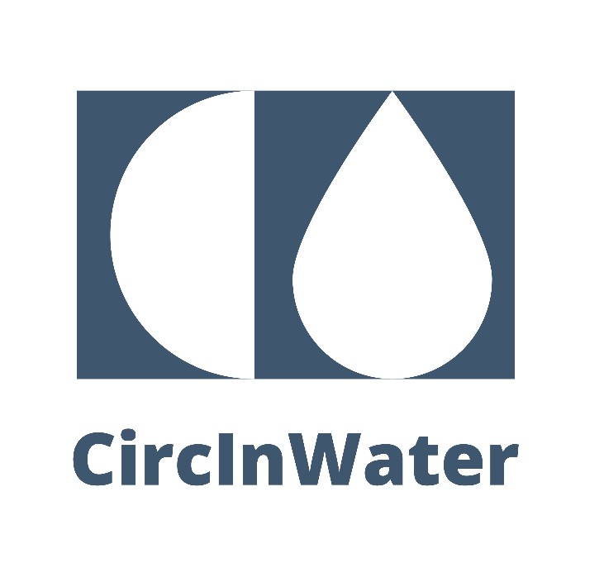

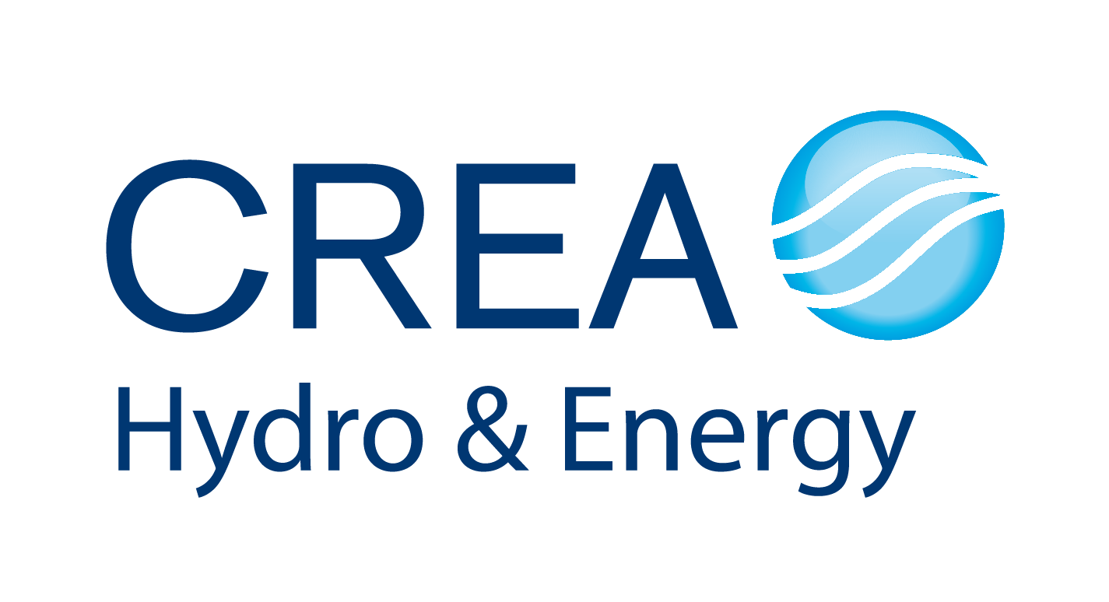
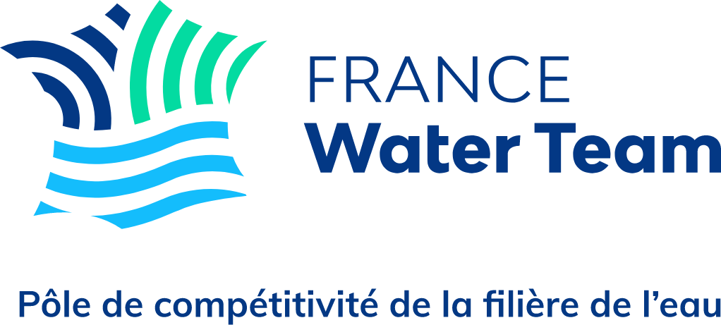
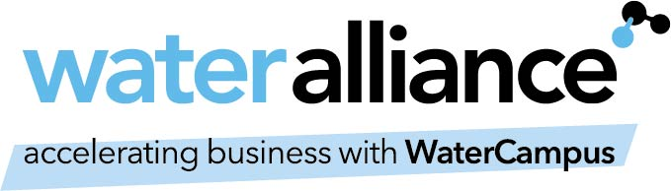
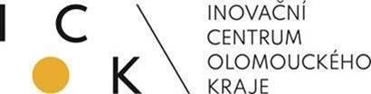
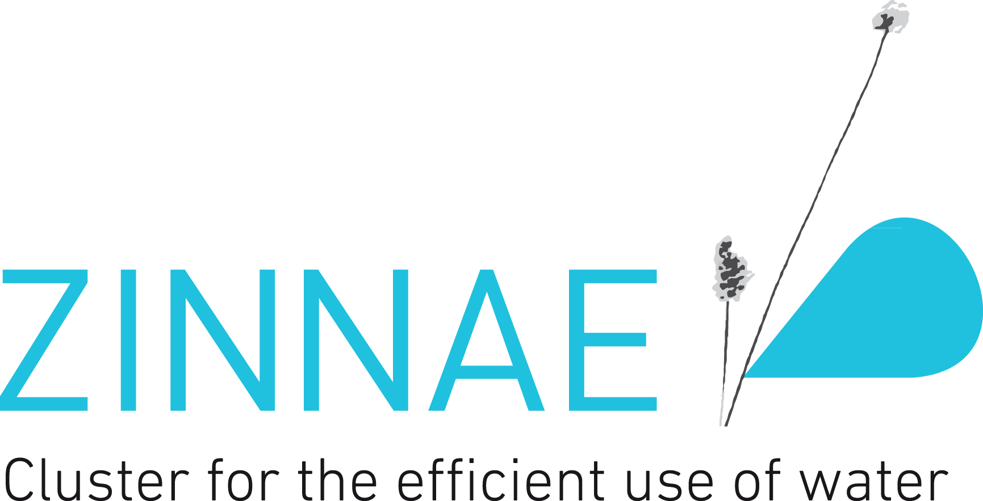
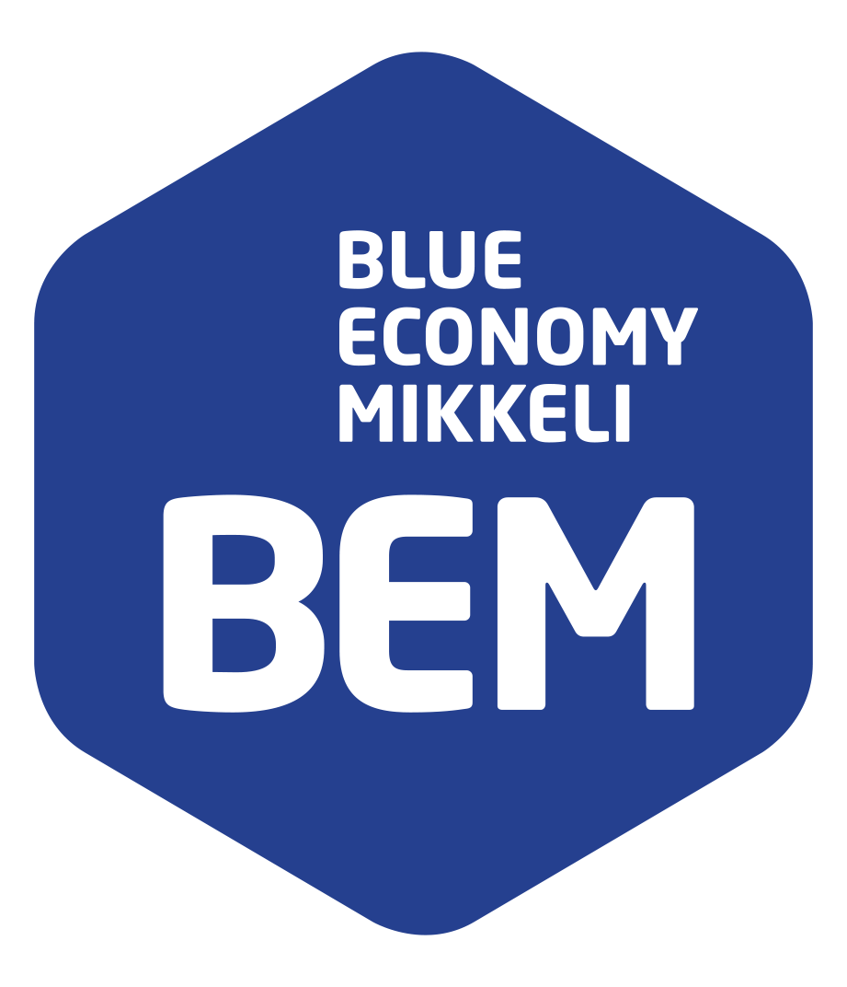
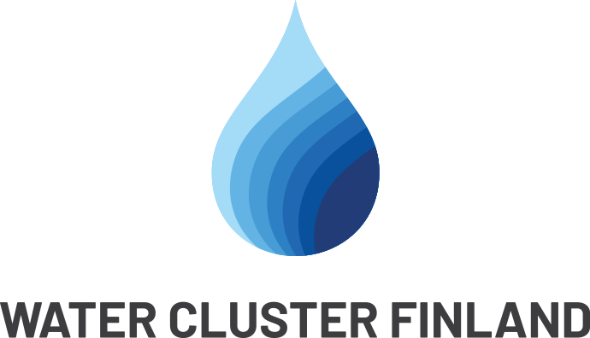

Applicants are entitled to apply and benefit from more than one CircInWater lump sum scheme, reaching a total max. funding of € 60.000 per SME.
Member states which joined the European Union in or after 2004.
ClusterXchange is a programme that supports short-term exchanges to better connect Europe's industrial ecosystems (see https://clustercollaboration.eu/clusterxchange ).
https://ec.europa.eu/regional_policy/policy/how/is-my-region-covered_en

